New Product September 2020

Go modular with the Secabo LITE series

Welcome to the LITE side of life!

With this new development of the Secabo TC LITE toggle press, Secabo is launching a lucrative modular system that opens up a multitude of new possibilities for price-conscious users. More flexibility thanks to easily exchangeable components, in short a basic product with great upgrade options. This means that the new LITE models have the advantage of retrofitting individual base plates or heating plates if necessary and simply replacing components.

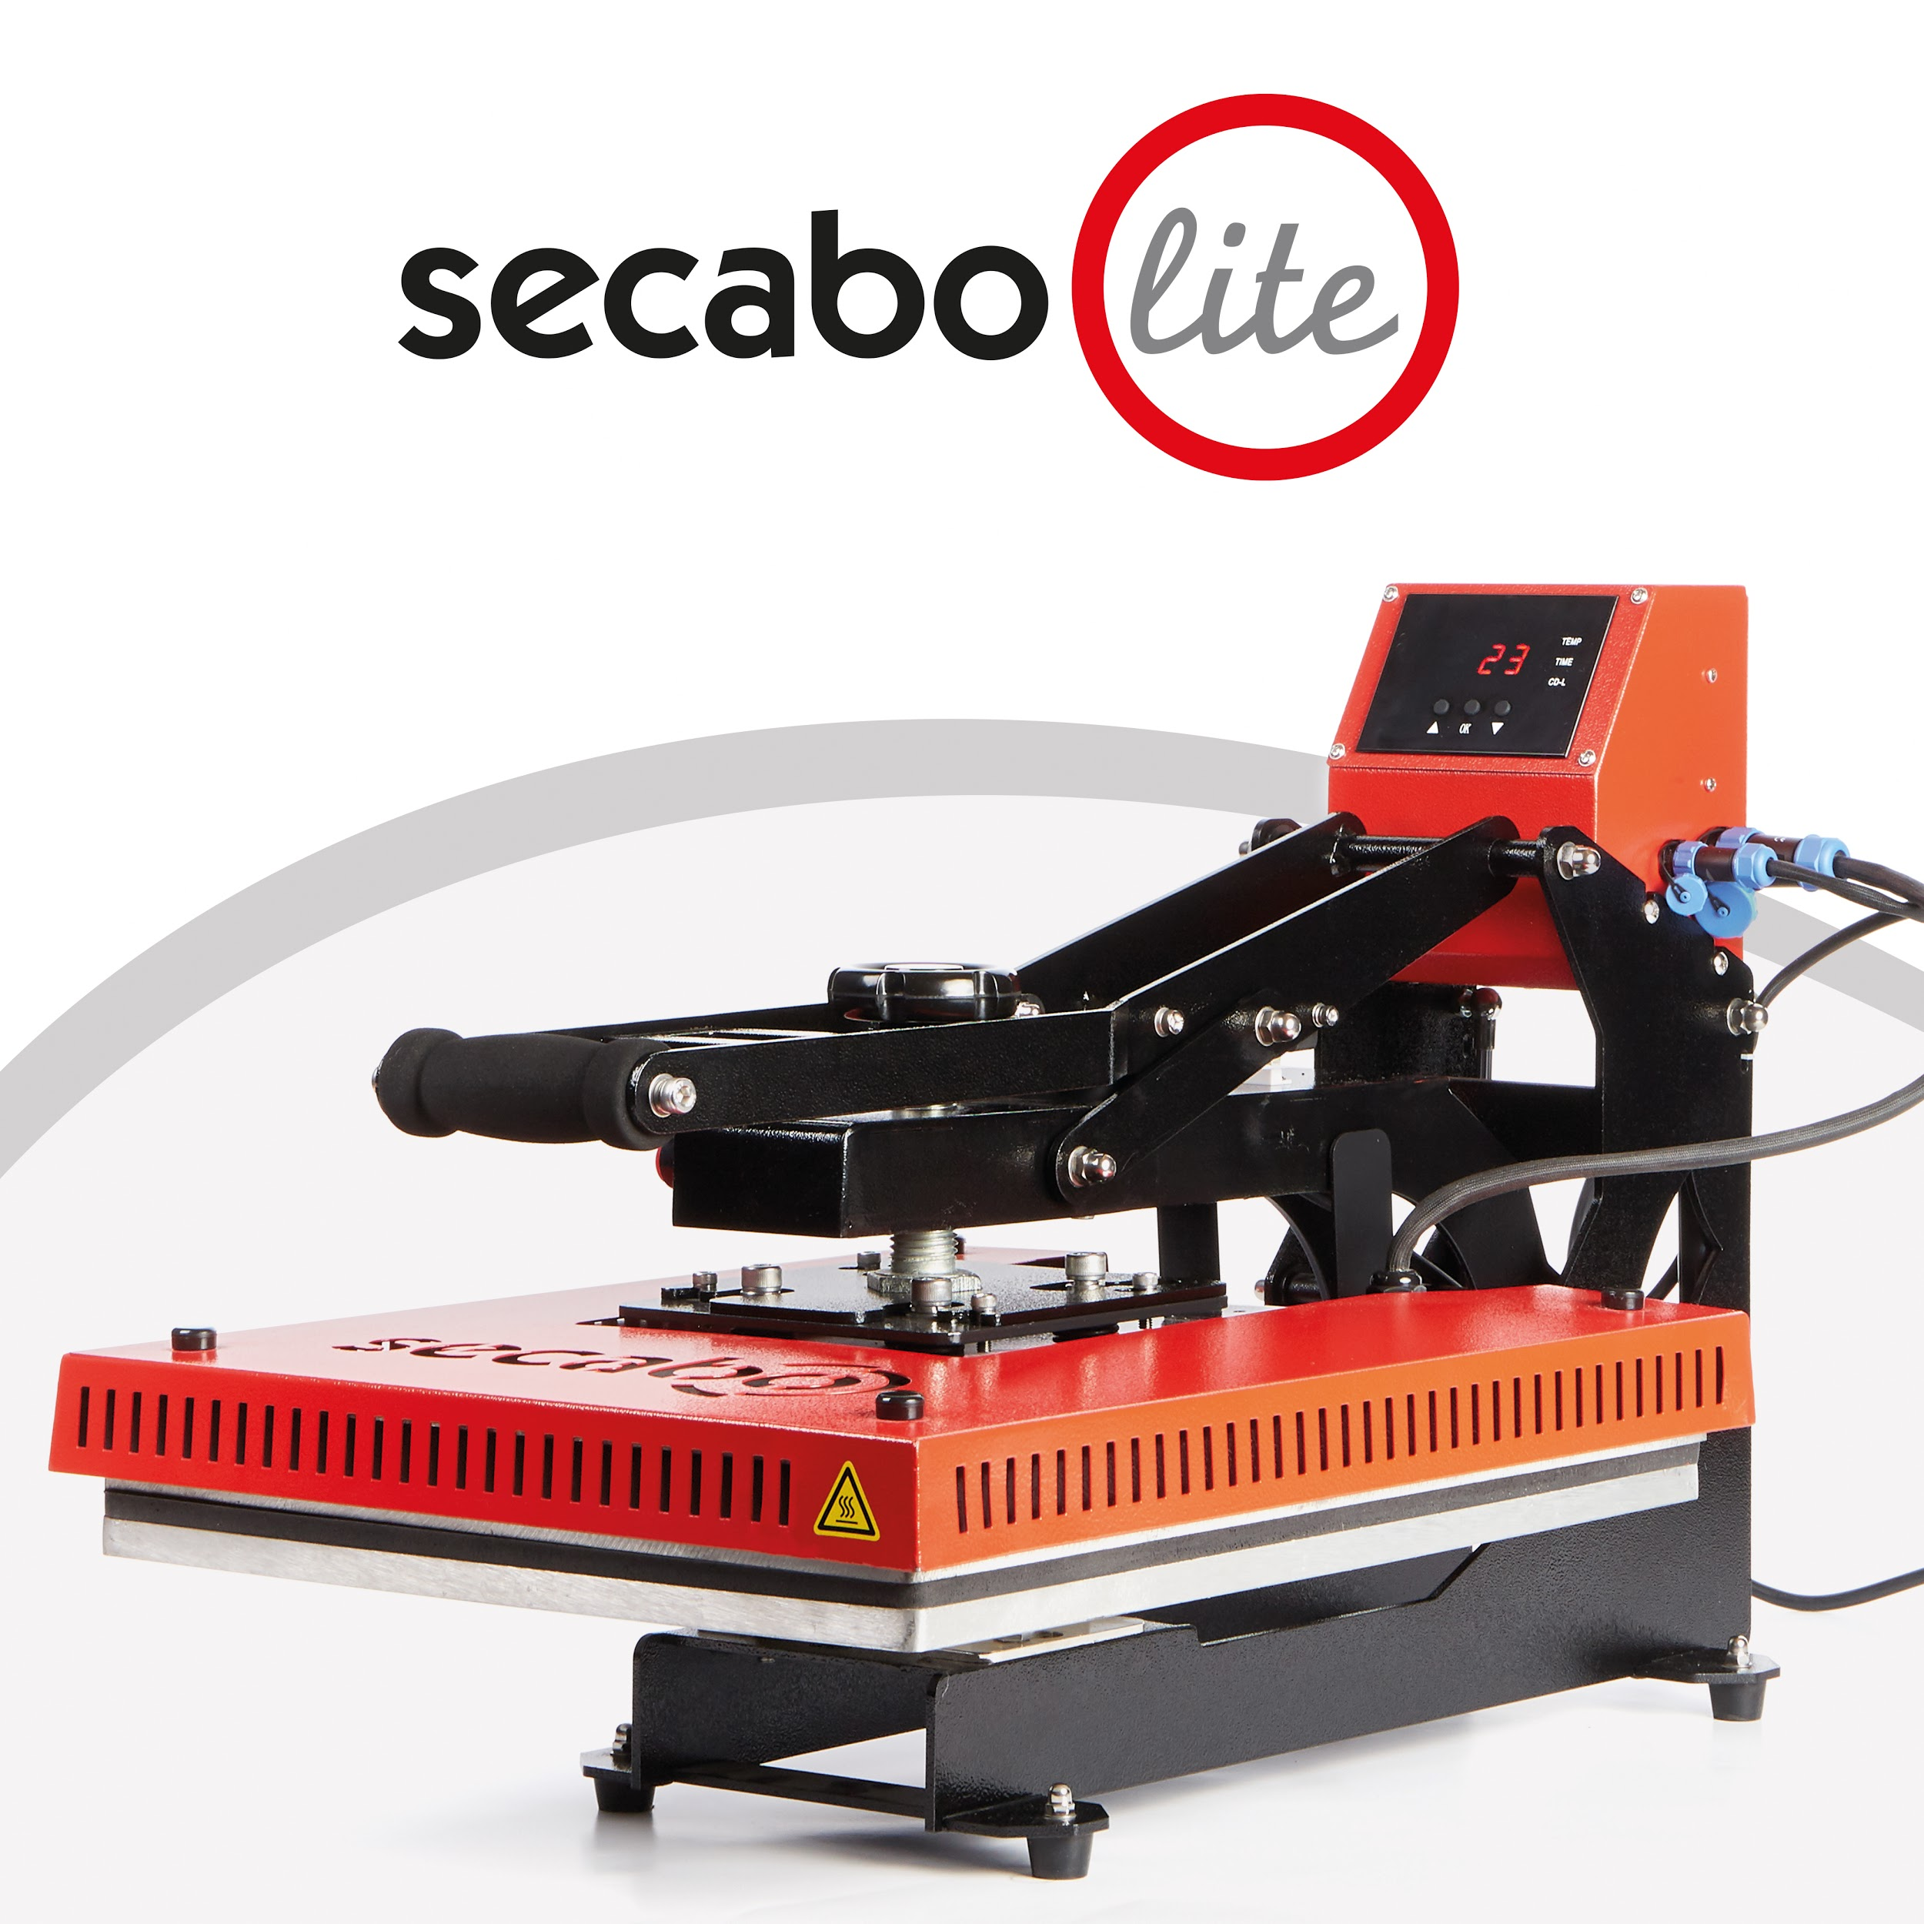
High comfort

The TC7 LITE (40cm x 50cm) heat press and the TC5 LITE (38x38cm) have an additional cover plate for the heating plate to protect the user from burns. The structure of the LITE series is fully modular, the control unit, heating plate, base plate and base frame can be disassembled and replaced in just a few simple steps. For example, the use of other heating plates is also made possible. The LITE transfer presses offer everything that makes textile transfers with Secabo so comfortable. All professional applications of the usual hot transfer processes such as flock foils, flex foils, sublimation, inkjet flex, etc. are of course possible.

For more information: www.secabo.com

SECABO - Machines for creators
Secabo offers a comprehensive hardware product portfolio for advertising technology, garment finishing and for digital finishing, such as vinyl cutters, heat presses, label finishers, flatbed cutters as well as matching software for simple operation thereof. Secabo products always include smart and innovative features that make them stand out from the competition.
Secabo represents a very good price-performance ratio. Development, service and quality control are located in Germany, manufacture takes place at its own location in Wolnzach in Europe as well as in Asia. The international sales in 80 countries is handled by the parent company Nepata Vertrieb GmbH seated at the company's headquarters in Wolnzach, Upper Bavaria, in the district of Pfaffenhofen an der Ilm.
The entire Nepata corporate group employs around 35 people. In addition to Secabo, the Nepata Group also operates Europe's largest online shop for advertising technology and textile finishing "YOW!" as well as the Nepata GmbH. The expert machine builder specializes in efficient film conveting and has developed a range of machines for rewinding, trimming or slitting along with suitable software solutions.

Contact person for the press

NEPATA Vertrieb GmbH
Julia Stowasser
Phone: +49 8442 95840-66
julia.stowasser@secabo.de

PRODUQTIV communication & design
Verena Schlegel
Phone: +49 8441 8710819
vs@produqtiv.de

